Lesson 4 Demo 11: Create Configmap from a Config File

This section will guide you to:

* Create a configmap from a config file

This lab has one sub-section, namely:

1. Creating a configmap from a config file

**Note:** If you don’t have an existing Kubernetes cluster, refer to the Demo 1.1 of Lesson 1.

**Step 1:** Creating a configmap from a config file

* Start the kubernetes cluster in the lab
* As the first step, create a directory at *configure-pod-container/configmap/* as shown below:

*sudo mkdir -p configure-pod-container/configmap*



* Download the sample files into *configure-pod-container/configmap/* directory using:   
    
  *sudo wget https://kubernetes.io/examples/configmap/game.properties -O configure-pod-container/configmap/game.properties*

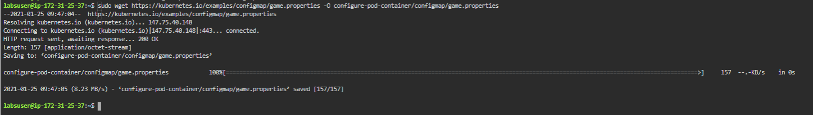

* You can use *kubectl create configmap* to create a configmap from an individual file or from multiple files as shown below:  
    
  *kubectl create configmap game-config-2 --from-file=configure-pod-container/configmap/game.properties*



* You can verify the created config map using ***kubectl describe configmaps game-config-2*** command as shown below:

